Assignment 2 | 22nd January 2021

Javascript Essentials | Jan 2021 B1

Question 1 What is the value of clothes[0] and why?

const clothes = ['jacket', 't-shirt'];

clothes.length = 0;

console.log(clothes[0]);

Answer. The value of clothes[0] will be undefined as in the second line of code we have assigned the length of the array to be 0 hence the declaration of the array will become null and the result will be “undefined”.

Whereas, if we delete the second line of code which is clothes.length = 0; the result will be jacket as the the value at index 0 of the array will be returned which is jacket.

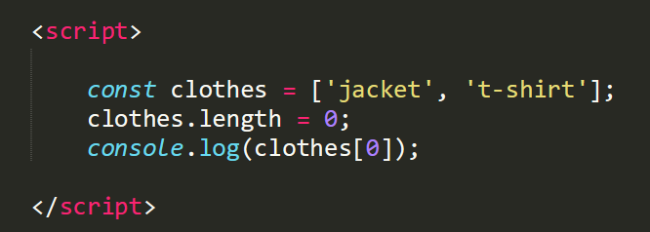

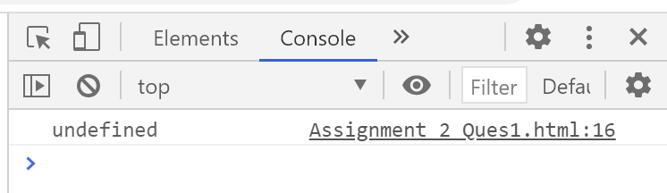

Question 2 Write a Javascript program to find the sum of all elements of a given array?

Answer.

